|  |
| --- |
| **A**  **SOFTWARE REQUIREMENT SPECIFICATION**  **ON**  **STUDENT INFORMATION SYSTEM**  **UNDER**  **NON-SYLLABUS PROJECT**  **DEPARTMENT OF COMPUTER ENGINEERING SESSION 2022-23**  **SUBMITTED TO:**  **DR. SIKHA GAUTAM**  **ASST. PROFESSOR**  **SUBMITTED BY:**  **HIMANSHU SHARMA (PIET21CS081)**  **JAHANVI SHARMA (PIET21CS083)**  DEPARTMENT OF COMPUTER ENGINEERING  POORNIMA INSTITUTE OF ENGINEERING & TECHNOLOGY, JAIPUR  (ACADEMIC YEAR 2022-23) (ODD) |

**LIST OF CONTENT**

|  |  |  |
| --- | --- | --- |
| Chapter 1 | 1. Introduction of the Project    * + Objective of the Project      + Types of Users      + Dependency      + Methodology Used |  |
| Chapter 2 | 1. Requirements    * + Functional Requirements      + Non-Functional Requirements      + Technology Used      + H/W Configuration      + Graphical User Interface |  |
| Chapter 3 | 1. Design    * + DFD      + UML |  |
| Chapter 4 | 1. Database Schema   Table-1  Table-2 |  |

|  |  |  |  |  |  |  |
| --- | --- | --- | --- | --- | --- | --- |
| Chapter 5 | 1. Conclusion |  |  |  |  |  |
|  |  |  |  |  |  |  |
|  |  |  |  |  |  |  |
| Chapter 6  Chapter 7 | 6. Snapshots Of Your Project   1. Code |  |  |  |  |  |
|  |  |  |  |  |  |  |

|  |
| --- |
| **DECLARATION**  I hereby declare that the Non-Syllabus Project report entitled **“STUDENT INFORMATION SYSTEM**" was carried out and written by me under the guidance of **DR. SHIKHA GAUTAM,** Assistant Professor, Department of Computer Engineering, Poornima Institute of Engineering and Technology, Jaipur. This work has not been previously formed the basis for the award of any degree or diploma or certificate nor has been submitted elsewhere for the award of any degree or diploma.  PLACE: JAIPUR  **HIMANSHU SHARMA (PIET21CS081)**  **JAHANVI SHARMA(PIET21CS083)**  DATE: |

**Chapter 1: Introduction of Project**

### 1.1 Objective of project

Student Information System is software which is helpful for students as well as the school authorities. In the current system all the activities are done manually. It is very time consuming and costly. Our Student Management System deals with the various activities related to the students.

In the Software we can register as a faculty as well as a student for every student the authentication code and the roll no is provided by the head of the department faculty and for the registration of a faculty the Registration ID and the authentication code is provided by the administrator the institute. In this project an admin can manage the faculty and take decision about the students like deletion of any student admin is authorized to create the token for the registration of the faculty as same as a faculty is authorized for creating token for the registration of a student.

### 1.2 Type of user

1. Administrator
2. Student
3. Faculty

### 1.3 Dependency

1. There will only be one administrator.
2. The delete operation is available only to the administrator.
3. To reduce the complexity of the system, there is no check on delete operation. Hence, administrator should be very careful before deletion of any record and he/she will be responsible for data consistency.
4. The login Id and password must be created by system administrator and communicated to the concerned user confidentially to avoid unauthorized access to the system.
5. It is assumed that a student registering for the subsequent semester has been promoted to that semester by the university as per rules and has paid desired university fee. 6 Registration process will be open only for specific duration
6. Qualification: At least matriculation and comfortable with English.
7. Experience: Should be well versed/informed about the registration process of the university.
8. Technical Experience: Elementary knowledge of computer

**1.4 Methodology used**

Explain waterfall model

**Chapter 2: Requirement Analysis**

**2.1 Functional Requirements**

1. A login facility for enabling only authorized access to the system.
2. System administrator will be able to add, modify or delete programme, school, scheme, paper and login information.
3. Students will be able to add/modify his/her details and register for papers to be studied in the current semester.
4. System administrator/Faculty will be able to generate reports.
5. So many

#### 2.2 No Functional Requirements

1. Availability
2. Security
3. Scalability
4. Maintainability
5. Reliability

#### 2.3 Technology Used

* MS-Windows Operating System
* HTML , CSS, Bootstarp, Javascript for designing front-end
* MYSQL for backend
* PLATEFORM: PHP LANGUAGE

#### 2.4 Hardware Specifications

* Screen resolution of at least 640 x 480 or above.
* Support for printer (dot matrix, deskjet, laserjet)
* Computer systems will be in the networked environment as it is a multi-user system.
* At least 1 GB RAM and 16 GB space of hard disk will be required to run the software.

**2.5 Graphical User Interface**

The ONSMS will have following user-friendly and menu driven interfaces

1. Login: to allow the entry of only authorized users through valid login Id and password.
2. School Details: to maintain school details.
3. Programme Details: to maintain programme details.
4. Scheme Details: to maintain scheme details of a programme.

**Chapter 3: Design**

**3.1 DFD**

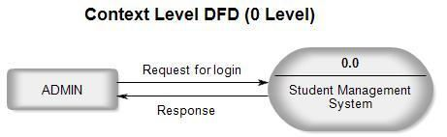

Context Level DFD (1 Level)

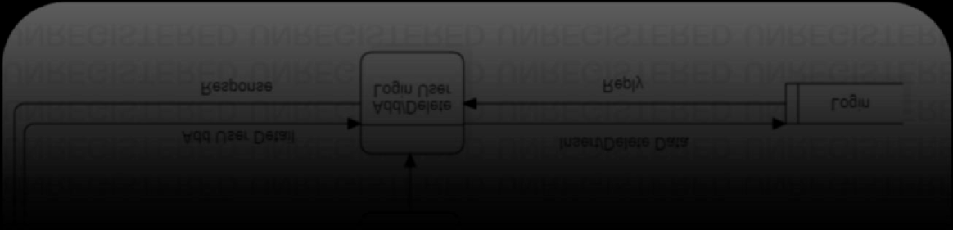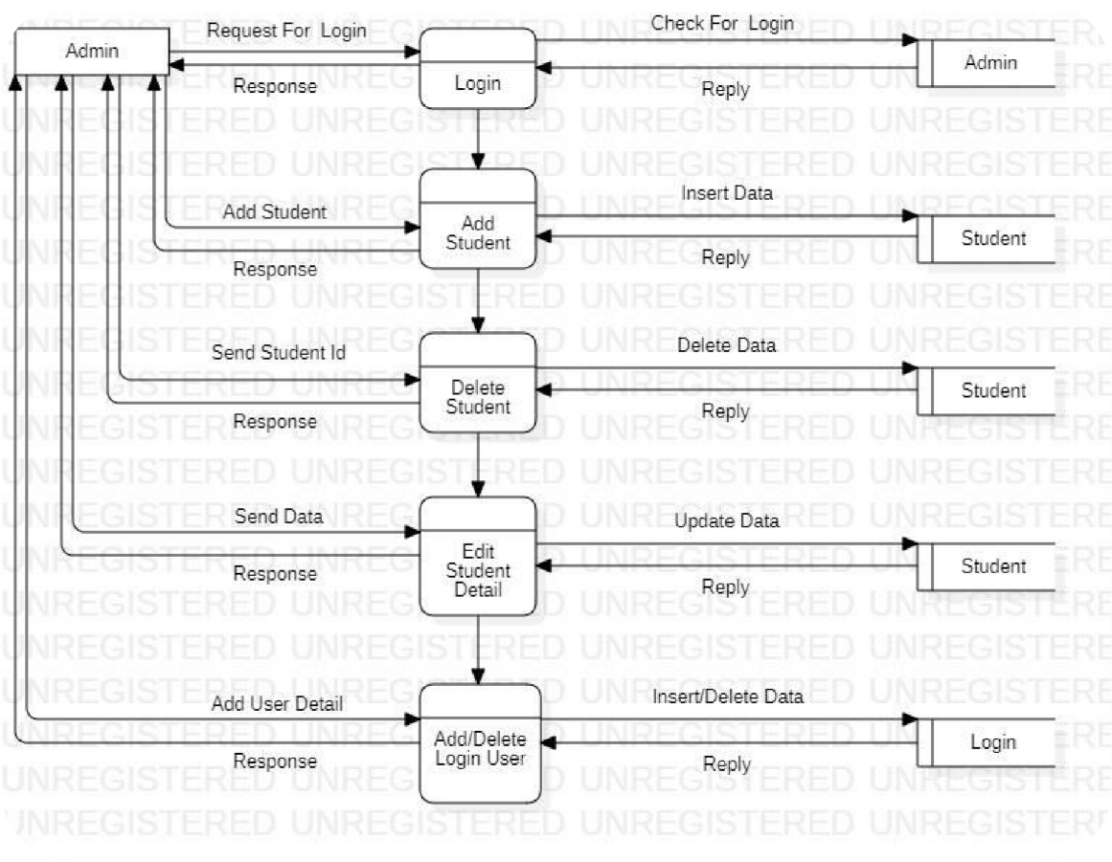

## 3.2 Use Case Diagram

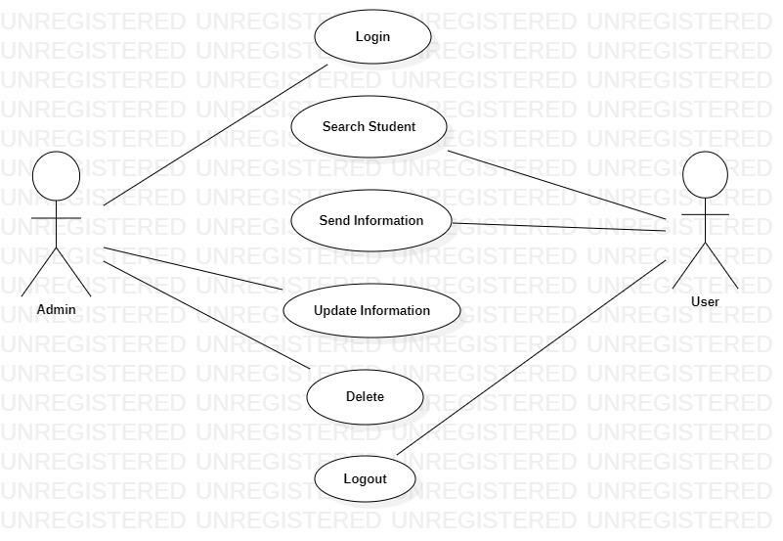

## 3.3 Class Diagram

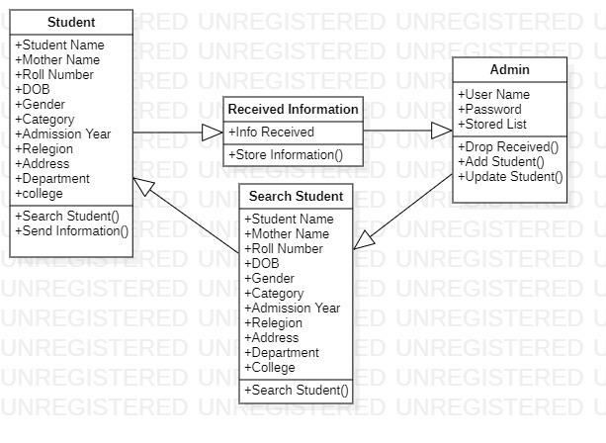

**Chapter 4: Database Schema**

**4.1 Table:1**

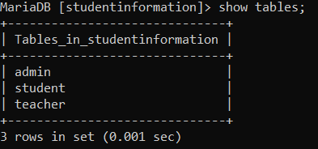

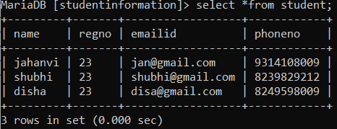

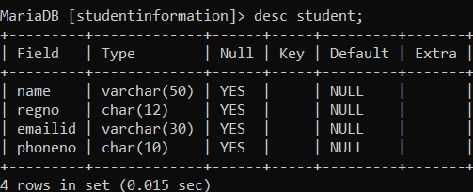

**4.2 Table:2**

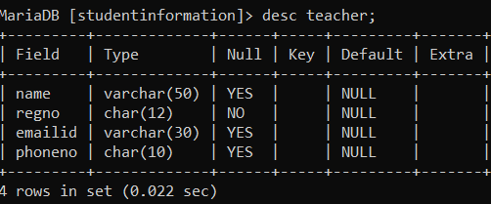

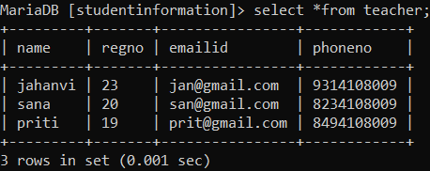

## Chapter 5: Conclusion

The primary purpose of the Student Information System is to manage, store and track the student's related data on a secured environment. This platform allows the admin to store student's academic records in one place and ensure the only authorized person can access the information.

## Chapter 6: Snapshots of Project

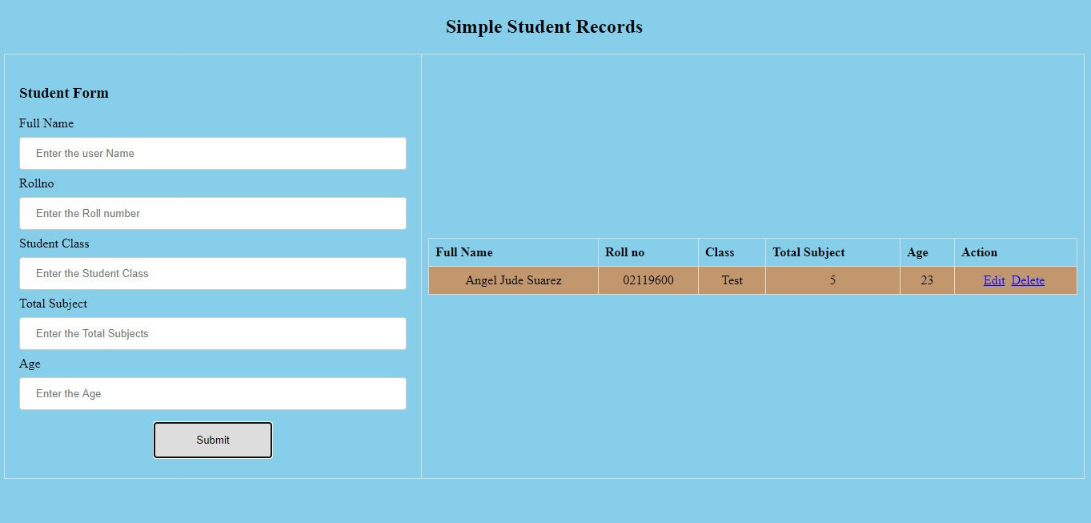

Chapter 7: Code

